Phase 2: Requirements Engineering

Student No: 202321283
Surname: MOKHABI
Project: Moderated Learning Management System (MLMS)
Development model: Waterfall, with V-Model verification and validation
Date: 9/10/2026
Week No: 2

Introduction
This document is the Phase 2 deliverable for the Moderated LMS. It covers three marked components:
- Stakeholder analysis and conflict resolution: identifying the stakeholders and their interests, listing the conflicts and ambiguities in the stakeholder statements, and explaining how you resolved each one.
- Software Requirements Specification (SRS): consisting of SRS following a recognized structure such as ISO/IEC/IEEE 29148, including functional and non-functional requirements, each uniquely identified, prioritized (MoSCoW) and verifiable. Provided that non-functional requirements must be measurable.
- Use case model: producing a Use Case Diagram covering all four actors, using include, extend and generalization where appropriate, writing fully dressed use case specifications (preconditions, main flow, alternative and exception flows, postconditions, business rules) for three use cases, one of which must be “Submit assignment”.
The document is the input to Gate 1. The requirements are derived from the case study and are frozen for the Waterfall baseline and design (Phase 3) begins. Every requirement is uniquely identified, prioritized using MoSCoW, and verifiable. Non-functional requirements are measurable, not aspirational.

Stakeholder analysis and conflict resolution

Stakeholder Analysis
- Principal: Interested in simplicity of the system for non-IT staff such as lectures, in students not seeing their marks before HoD checking and in smooth school operation.
- Lectures: Interested in fast marking workflow, ability to grant extensions, and minimal administrative overhead.
- Heads of Department (HoD): Interested in seeing every departmental mark before release, and a quantified, consistent late-penalty policy.
- Students: Interested in resubmitting before deadline, written feedback not just a number, and late work been rejected without recourse.
- Student Representative: Interested in fairness and transparency of assessment process.
- IT officer: Interested in the system that works fully offline and compatible on old computer hardware with 800 students, and protected passwords.
- System administrators: Interested in Managing accounts, departments, courses, lecturer assignment, enrolment and lecturer assignments, and system integrity.
- Parents/Guardian: Interested in fairness of assessment, and protection of learners' personal data
Eight stakeholder groups were identified from the brief and the school context. Their interests directly shaped the SRS.

Conflicts and Ambiguities
ID | Source | Conflict/ Ambiguity
C1 | Lecturer vs Principal | Whether students must get marks as soon as I have marked or students must not see any mark until checked by the HoD.
C2 | HoD vs Student representative | Whether late work loses 10%/day for up to 3 days then zero or late work should not simply be penalized or rejected.
C3 | Resubmission vs marking | Can a student resubmit after the lecturer has  marked? Which submission counts?
C4 | Extensions vs Penalty | Whether lecture grants extensions to individuals or to whole classes, is there a penalty for extension.
C5 | IT Officer vs. System scope | Whether "800 students" means concurrent users or total enrolment.
C6 | Principal vs Breadth | “The system must be simple” vs the full role/permission surface
A1 | HoD statement | "For each day it is late", calendar days or working days?
A2 | IT officer | “Respond quickly even with 800 students”, the word “quickly” is unmeasurable
A3 | Student rep statement | "Written feedback, not just a number", mandatory or optional?
A4 | Brief | “Every user logs in with username and password”, password policy, account lockout, initial passwords unspecified
A5 | HOD statement | “Late work should lose 10% of the available mark…”, does the “available mark” refer to the assignment total mark or to the achieved mark?

Five genuine conflicts and three material ambiguities were found in the stakeholder statements.

Conflict Resolution
ID | Resolution
C1 | The system enforces a mandatory moderation step, meaning marks are invisible to students until the HoD releases them. The Lecturer's preference is a workflow convenience, not a policy requirement. It was stated that "Students must not see any mark until it has been checked by the Head of Department." The Principal's statement is therefore authoritative.
C2 | Late work is accepted and penalized, never rejected. The HoD's penalty rule presupposes that late work is accepted otherwise there would be nothing to penalize. "Late work should not simply be rejected" statement is therefore consistent with the HoD's rule, not in conflict with it. Reading the two together yields a single coherent rule.
C3 | The latest submission before the effective deadline is the one marked. A submission cannot be replaced once the effective deadline has passed or once marking has begun,  whichever is first. This protects lecturers from re-marking several resubmissions for single student.
C4 | Extensions apply to individual students only. The penalty can never make a mark negative below zero, after 3 days late the mark is 0 but feedback is still recorded.
C5 | Interpreted as 800 total enrolled students, not 800 concurrent users. The system runs on a single school computer, or local network and the IT Officer's concern is about old hardware and unreliable internet. 800 simultaneous users on a single school computer is not plausible, 800 total records are trivially handled by SQLite.
C6 | The Student and Lecturer interfaces are kept minimal (shallow menus, clear prompts). Moderation, audit and administrative power sits behind the HoD and Administrator roles. This satisfies the Principal's concern without sacrificing the HoD's oversight or the school's audit obligations.
A1 | Calendar days. The HoD's rule was interpreted literally.
A2 | This is quantified on the non-functional requirements. $Login ≤ 2s$ and $assignment list≤ 1s$ with 800 user accounts and realistic data, verified by a timed system test.
A3 | Feedback is mandatory when a mark is recorded, the system rejects a mark without feedback.
A4 | Making minimum policy assumptions: passwords ≥ 8 characters, accounts lock for 5 minutes after 5 failed attempts, administrator issues initial passwords which users change at first login. Logged in the SRS assumptions so the school can tighten them without redesign.
A5 | Applied to the achieved mark, floored at zero. The HoD said "10% of the available mark", which is read as 10% of the maximum mark subtracted from the achieved mark.

Every resolution above is recorded as a functional requirement, non-functional requirement or business rule, so the conflict analysis is auditable rather than asserted.

Software Requirements Specification (SRS)
This SRS specifies the complete functional and non-functional requirements of the Moderated LMS for a secondary school, as the basis for design (Phase 3), implementation (Phase 4) and testing (Phase 5). It follows the structure of ISO/IEC/IEEE 29148 and the requirements are prioritized using MoSCoW (Must / Should / Could / Won't) and are verifiable.

Scope
The product is an offline C++17 application (console UI) with SQLite persistence, running on a single school computer, managing users, departments, courses, assignments, submissions, marking, moderation and mark release for students, lecturers, HoDs and an administrator. Out of scope (per brief): online payment, video conferencing, automated grading, plagiarism detection, web/mobile interfaces.

Definitions
- Effective deadline: The assignment deadline, or the extended deadline for a specific student.
- Late penalty: A reduction of 10% of the maximum mark per late calendar day, up to 3 days, zero thereafter.
- Moderation: The HoD's review and approval of a mark before it is released.
- Released mark: A moderated mark approved and released by the HoD, the only mark a student may see.
- Audit entry: A record of a mark change: who, when, old value, new value, reason.
- MoSCoW: Must / Should / Could / Won't (this phase) prioritization.
- Submission: A versioned piece of student work attached to an assignment.

User characteristics
Students (≈800, IT-literate but not experts), lecturers (subject specialists, not IT experts), HoDs (senior teachers), administrator (the IT officer). All interact through role-specific menus.

Assumptions and dependencies
- A01: The school provides a compatible machine and a technician to install the binary.
- A02: Users have basic computer literacy such as login and menu navigation.
- A03: A single SQLite file is the system of record; backups are the school's responsibility.
- A04: Peak concurrent usage is in the order of tens of sessions.

Functional requirements
ID | Requirement | MoSCoW | Verification
FR1 | The system shall authenticate every user with a username and a password before granting access to any function. | Must | Llogin with valid and invalid credentials
FR2 | The system shall store passwords as salted hashes using a recognized algorithm (Argon2id or bcrypt); plaintext passwords shall never be stored or logged. | Must | Inspection of the database and test to confirm that hashes differ from plaintext and are salted.
FR3 | The system shall assign each authenticated user exactly one role: Student, Lecturer, HoD or Administrator. | Must | Each role can perform only its permitted actions.
FR4 | The Administrator shall be able to create, update, deactivate and delete user accounts. | Must | CRUD operations on users.
FR5 | The Administrator shall be able to create, update and delete departments and courses. | Must | CRUD operations on departments and courses.
FR6 | The Administrator shall be able to assign lecturers to courses and enroll students on courses. | Must | Assign lecturer, enroll student, and verify linkage in the database functionalities.
FR7 | The Lecturer shall be able to create an assignment for a course they teach, with a title, description, deadline and maximum mark. | Must | Create assignment and verify it appears to enrolled students.
FR8 | The Lecturer shall be able to grant an individual extension to a student for an assignment, specifying a new effective deadline and a reason. | Must | Extension recorded, effective deadline updated and audit entry created.
FR9 | The students shall be able to view the courses and assignments they are enrolled on. | Must | Enrolled assignments visible, non-enrolled assignments not visible.
FR10 | The student shall be able to submit work for an assignment. | Must | Submission stored with timestamp and version.
FR11 | The student shall be able to resubmit work before the effective deadline, and each resubmission is stored as a new version. | Must | Multiple versions stored and latest submission before deadline marked.
FR12 | The Lecturer shall be able to record marks and written feedback for a submission before moderation, feedback is mandatory. | Must | Mark without feedback rejected, and mark with feedback saved.
FR13 | The system shall compute the late penalty automatically: 10% of the maximum mark per late calendar day, for up to 3 days, and zero from the 4th late day. | Must | Boundary tests: on-time, day 1, day 2, day 3, day 4, day 5 etc..
FR14 | The system shall record every mark change in an audit log containing user, timestamp, old value, new value, and reason. | Must | Changes on a mark, verify a complete audit entry.
FR15 | The HoD shall be able to view all marks for all courses in their department before release. | Must | HoD sees department-wide marks and other HoDs' departments not visible.
FR16 | The HoD shall be able to moderate and release marks, and a mark is visible to a student only after release. | Must | Student cannot see an unmoderated mark; can see a released one.
FR17 | The student shall be able to view released marks and written feedback for their submissions. | Must | Released marks visible, and unreleased marks not visible.
FR18 | A lecturer shall be able to extend the deadline for a whole class, and such extensions shall be shown on the student's assignment view. | Could | Extended deadline for whole class and extension shown on assignment.
FR19 | The system shall report errors in plain language. | Must | Invalid input and simulated DB errors produce a clean message and a non-zero return code.
FR20 | The system shall display the submission life cycle state for each submission: submitted, late, marked, moderated, released. | Must | State transitions match the state machine diagram.
FR21 | The system shall notify a student when a mark is released (e.g., on next login). | Could | Notification appears after release.
FR22 | The Administrator shall be able to view the audit log for any mark. | Should | Audit entries visible and filterable.

Non-functional requirements
ID | Requirement | MoSCoW | Verification
NFR1 | A login shall complete within 2 seconds when the database contains 800 students, 50 lecturers, 20 HoDs, 5 administrators, 100 courses and 5,000 submissions, on the baseline machine. | Must | Timed test
NFR2 | Viewing a student's assignment list shall complete within 2 seconds. | Must | Timed test.
NFR3 | Recording of mark, feedback, audit entry shall complete within 2 seconds. | Must | Timed test.
NFR4 | Passwords shall be stored as salted hashes using Argon2id (or bcrypt) with a per-user random salt, meaning plaintext or reversible encoding shall not appear in the database or logs. | Must | Database inspection, grep for plaintext and unit test on the hash function
NFR5 | All database access shall use parameterized queries, no SQL string concatenation shall appear in the data-access layer. | Must | Code review, and static analysis
NFR6 | A user shall be able to perform only the actions permitted by their role and unauthorized actions shall be refused and logged. | Must | Role-based test matrix across all four roles.
NFR7 | The system shall run offline on a baseline machine running a current Linux or Windows OS with at least 4 GB RAM and 2 GB free disk space; no network connection shall be required at any point. | Must | Run on a school-equivalent machine with networking disabled.
NFR8 | The system shall not crash on invalid input or database errors; it shall report the error and continue or exit cleanly. | Must | Fuzz-style input tests and database failures.
NFR9 | Every mark change shall produce an audit entry within the same transaction as the change; no mark change shall be possible without an audit entry. | Must | Transactional test: force a failure after the mark write and verify rollback.
NFR10 | The business-logic layer shall achieve at least 70% line coverage from automated unit tests. | Must | Coverage report from the CI pipeline.
NFR11 | The code shall compile with no warnings | Should | CI build log.
NFR12 | A new Lecturer shall be able to mark a submission within 5 minutes of first login, using only on-screen prompts. | Should | UAT with two lecturers and timed observation.
NFR13 | A new Student shall be able to submit an assignment within 3 minutes of first login, using only on-screen prompts. | Should | UAT with two students and timed observation.
NFR14 | The system shall store only the personal data necessary for its function (name, username, password hash, role, department, enrolment, submissions, marks, feedback, audit entries) and shall not transmit any data over a network. | Must | Data dictionary review, network monitor during operation.
NFR15 | The system shall provide a documented backup procedure that copies the SQLite file to a timestamped location, and a documented restore procedure that recovers the system to a working state. | Should | Installation guide and rehearsal of backup and restore.
NFR16 | The console UI shall be usable with a screen reader and shall not rely on color alone to convey status. | Should | Manual accessibility check with a screen reader.

Business rules
BR1: A mark is released to a student only when its submission has reached the released state, which requires HoD moderation.
BR2: A late submission is accepted and its achieved mark is reduced by 10% of the maximum mark per late calendar day, for up to three days; from the fourth late day onward the mark is zero.
BR3: An extension has an owner (Lecturer), a student, an assignment, a new effective deadline, and a reason; it is recorded in the audit log.
BR4: Lateness is computed against the effective deadline.
BR5: Each submission is stored as a new version; the latest version before the effective deadline is the one marked.
BR6: A user may perform only the actions permitted by their role.
BR7: A mark cannot be saved without written feedback.

Use Case Model
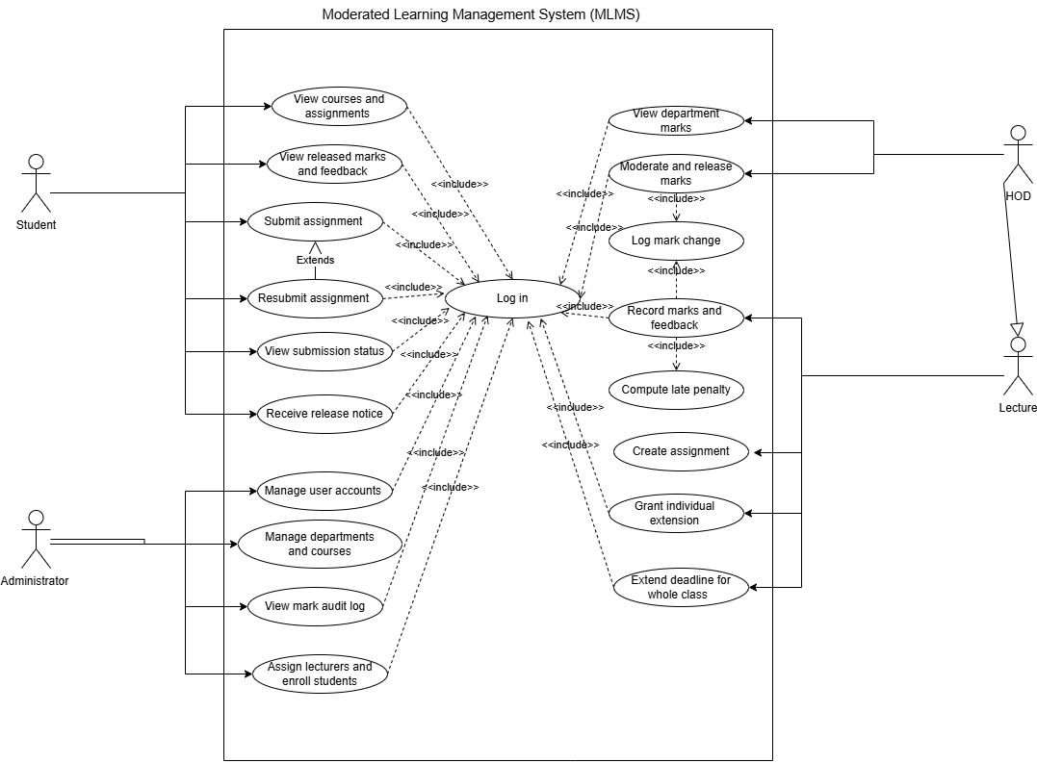

The model covers all four actors. Log in is included by every functional use case, since no action is available unauthenticated. UC-05a Resubmit assignment includes Submit assignment (it occurs only under the condition “before the effective deadline and before marking”). Log mark change is included in Moderate and release marks as well as in Record marks and feedback. Actor generalization: a Head of Department is a specialized Lecturer because the HOD can perform all lecturer functions for their department plus moderation/release, drawn as a generalization arrow from HoD to Lecturer. This also simplifies the access-control design in Phase 3, where the HoD role will inherits lecturer permissions.

Use case identification
ID | Name | Primary User
UC01 | Log in | Student, Lecturer, HoD, Administrator
UC02 | View courses and assignments | Student
UC03 | View submission status | Student
UC04 | Submit work | Student
UC05 | Resubmit work | Student
UC06 | View marks and feedback | Student
UC07 | Receive release notice | Student
UC08 | Create assignment | Lecturer
UC09 | Grant individual extension | Lecturer
UC10 | Extend deadline for whole class | Lecturer
UC11 | Record marks and feedback | Lecturer
UC12 | Compute late penalty | System
UC13 | Log mark change | System
UC14 | View department marks | HoD
UC15 | Moderate and release marks | HoD
UC16 | Manage user accounts | Administrator
UC17 | Manage departments and courses | Administrator
UC18 | Assign lecturers and enroll students | Administrator
UC19 | View mark audit log | Administrator

Fully dressed use case specifications
Use case spec | Log in
Preconditions | The user has a valid account created by the Administrator.
Main flow | The system prompts for username and password, the user enters credentials, the system hashes the entered password and compares it with the stored salted hash, On a match, the system loads the user's role and displays the role-specific menu and then the system logs the login event.
Alternative flow | - A1: At step 3, if the hash does not match, the system displays a generic "invalid username or password" message not distinguishing which was wrong. The system increments a failed-attempt counter for that username. After 5 failed attempts, the account is temporarily locked for 15 minutes. Then the flow returns to step 1.  - A2: At step 3, if the username does not exist, the system behaves identically to A1 to avoid revealing which usernames exist.
Exception flow | E1: At step 3, if the database is unavailable, the system reports the error in plain language and exits cleanly.
Postconditions | The user is authenticated, their role is loaded and the role-specific menu is displayed.
Business rules | BR6

Use case spec | Submit assignment
Preconditions | Student is logged in, the student is enrolled in the course, the assignment exists and marking of a previous submission has not begun.
Main flow | The system displays the student's enrolled assignments, the student selects an assignment, the system displays the assignment details (title, deadline, effective deadline, maximum mark), the student enters or uploads their work, the system validates the input (non-empty, within size limits), the system records the submission with the current timestamp and version number, the system determines lateness against the effective deadline, if on time, the system sets the state to submitted, and the system confirms the submission to the student.
Alternative flow | - At step 7, if the current time is after the effective deadline: the system sets the state to late, the system computes the late penalty per BR2 and stores it with the submission, it informs the student that the submission is late and shows the penalty and the flow continues at step 9.  - At step 4, if a submission already exists and the effective deadline has not passed: the system stores the new work as a new version, it marks the previous version as superseded but retains it, and then the flow continues at step 6 with the new version.  - At step 4, if a submission already exists and the effective deadline has passed: the system treats the new work as a late resubmission, it stores a new version and computes the late penalty and the flow continues at step 6.
Exception flow | - At step 2, if the student is not enrolled on the course: the system displays an error and returns to the assignment list.  - At step 3, if the assignment no longer exists: the system displays an error and returns to the assignment list  - At step 5, if the work is empty or exceeds the size limit: the system rejects the input, explains why, and returns to step 4.  - At step 6, if the database write fails: the system rolls back the transaction, reports the error in plain language, and returns to step 4. No partial submission is stored.
Postconditions | A new submission version is stored, timestamped, the submission state is submitted (on time) otherwise late. If late, the late penalty is computed and stored with the submission, and the lecturer can see the submission.
Business rules | BR2, BR4, BR5

Use case spec | Moderate and Release Marks
Preconditions | The HoD is authenticated, At least one submission in the department has been marked by a Lecturer.
Main flow | The system lists the HoD's department courses, the HoD selects a course, the system lists all marked submissions for that course, with student, assignment, raw mark, late penalty and final mark. The HoD reviews the marks. The HoD approves the marks and chooses "Release", the system sets each approved submission's state to released, the system makes the marks and feedback visible to the students, and then the system confirms the release to the HoD.
Alternative flow | - At step 4, if the HoD adjusts a mark: The system prompts for a reason, the system records an audit entry (who, when, old value, new value, reason). The system updates the mark, the flow continues at step 5.  - At step 4, if the HoD rejects a mark: The system returns the submission to the Lecturer with a note, the submission's state reverts to marked with a "returned" flag and the Lecturer is shown the note on next login.  - At step 5, if the HoD chooses "Release all": The system releases all approved marks for the course in a single transaction.
Exception flow | - At step 3, if there are none: the system informs the HoD and returns to the course list.  - At step 6, if the transaction fails: the system rolls back all releases, reports the error, and returns to step 4. No partial release occurs.
Postconditions | Approved marks are in the released state, and released marks are visible to the students concerned. Any changes made by the HoD during moderation are recorded in the audit log.
Business rules | BR1, BR6

Gate 1 Readiness and Conclusion
Phase 2 has converted incomplete and conflicting interview statements into a verifiable requirements baseline: eight stakeholders were analyzed, six conflicts and five ambiguities were each resolved with an explicit, justified decision, the SRS contains 22 functional and 16 non-functional requirements exceeding the minima of 12 and 6 and they are all uniquely identified, MoSCoW-prioritized, and each carrying a stated verification method, with every NFR expressed measurably and the use case model covers all four actors with include, extend and actor generalization, plus three fully dressed specifications including “Submit assignment”. Two engineering judgements deserve emphasis at Gate 1. First, the clash between the lecturer's speed and the Principal's control was resolved not by compromise but by workflow design: the moderation step is what makes immediate lecturer feedback safe, so both interests are fully served rather than traded off. Second, the HoD's quantified late-penalty rule and the student representative's fairness concern were resolved as a pairing. Both decisions now constrain the design phase, where the late-penalty calculation will be isolated behind a strategy interface precisely because the school has already shown that assessment rules change. On approval at Gate 1, this SRS and the use case model are frozen as the Phase 3 baseline and any later change will enter through the change-control procedure.

References
- Sommerville, I. (2016) Software Engineering. 10th edn. Boston: Pearson.
- CS4433 (2026) CS4433 Final Project — Individual Assignment: Moderated Learning Management System. Moderated Learning Management System (MLMS).
- ISO/IEC/IEEE. (2018). ISO/IEC/IEEE 29148:2018 — Systems and Software Engineering — Life Cycle Processes — Requirements Engineering.
- Boehm, B. W. (1989). Software Risk Management. IEEE Computer Society Press.

